1. Capsomulin is the only one based on the 4 drugs plotted that decreases tumor size.

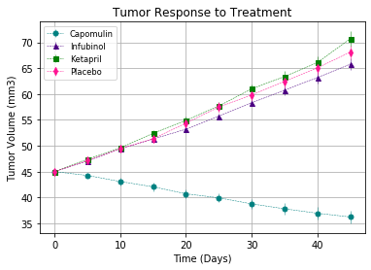

1. Looking at the raw data, Ramicane also decreases tumor size. It actually has a smaller average tumor size than capsomulin

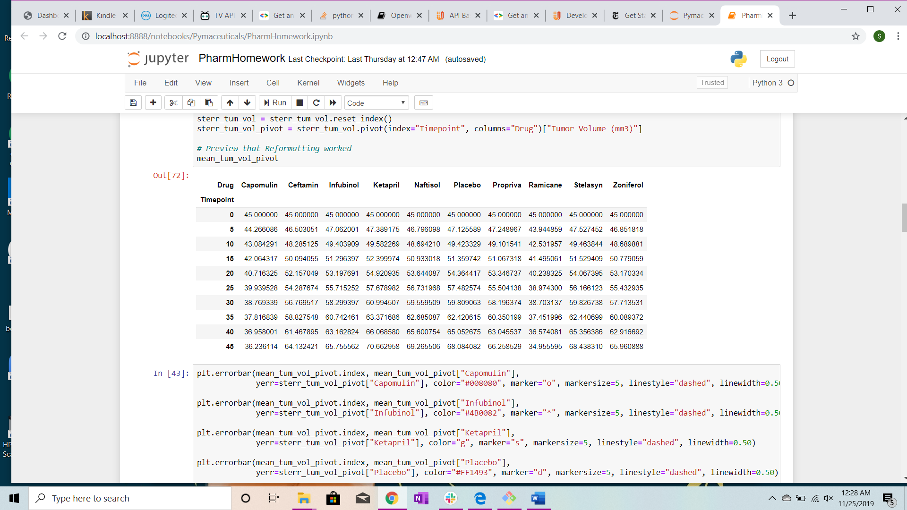

1. Capomulin has the best survival rate at 84%, with 21 of the 25 rats surviving.
2. 